AI Assistant Coding
Assignment-4

Name of Student : K.HariHaran
Enrollment No. : 2303A52402
Batch : 37

Task Description-1
• Zero-shot: Prompt AI with only the instruction. Write a Python function to determine
whether a given number is prime
Expected Output-1
• A basic Python function to check if a number is prime, demonstrating correct logical
conditions without relying on examples or additional context
Prompt:
Write a Python function to determine whether a given number is prime.
Code:
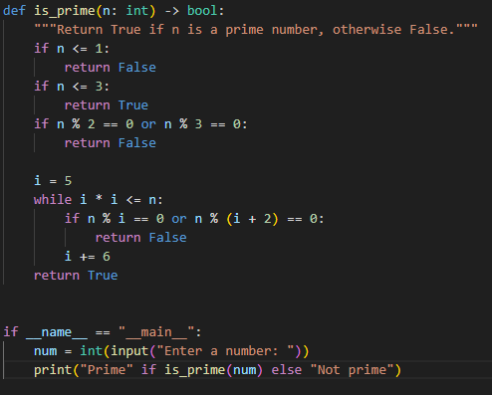

Output:

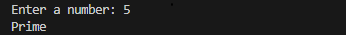

Justification:
In zero-shot prompting, only the instruction is provided without examples. The AI relies on its prior knowledge to generate the solution. This demonstrates the model’s ability to understand the problem and apply correct logical conditions independently.
Task Description-2
• One-shot: Provide one example: Input: [1, 2, 3, 4], Output: 10 to help AI generate a
function that calculates the sum of elements in a list.
Expected Output-2
• A correct conversion function guided by the single example.

Prompt:
Example:
Input: [1, 2, 3, 4]
Output: 10
Write a Python function to calculate the sum of elements in a list.

Code:
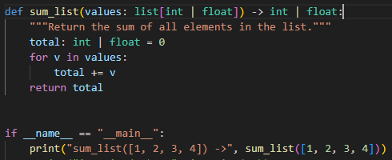

Output:

Justification:
One-shot prompting provides a single example to guide the AI. The example helps clarify the expected operation and output format. This improves accuracy by reducing ambiguity compared to zero-shot prompting.

Task Description-3
• Few-shot: Give 2–3 examples to create a function that extracts digits from an
alphanumeric string.
Expected Output-3
• Accurate function that returns only the digits from alphanumeric string.

Prompt:
Example1:Input:"a1b2c3"→Output:"123"
Example2:Input:"abc2025xyz"→Output:"2025"
Example 3: Input: "x9y" → Output: "9"
Write a Python function to extract digits from an alphanumeric string.

Code:
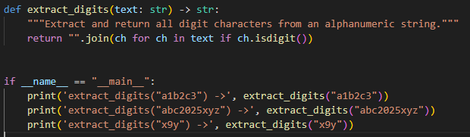

Output:
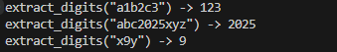

Justification:

Few-shot prompting uses multiple examples to show clear input–output patterns. These examples help the AI identify the exact rule for extracting digits. As a result, the generated function is more precise and reliable.

Task Description-4
• Compare zero-shot vs few-shot prompting for generating a function that counts the
number of vowels in a string.
Expected Output-4
• Output comparison + student explanation on how examples helped the model.

Prompt:
Zero-Shot Prompt
Write a Python function to count the number of vowels in a string.

Few-Shot Prompt
Example 1: "hello" → 2
Example 2: "AI Tools" → 4
Example 3: "xyz" → 0
Write a Python function to count vowels in a string.

Code:
Zero-Shot Prompt
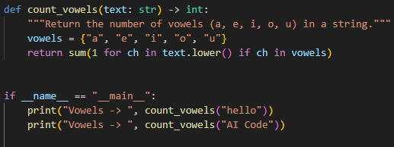

Few-Shot Prompt
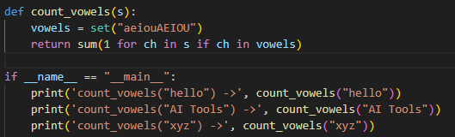

Output:
Zero-Shot Prompt

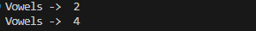

Few-Shot Prompt

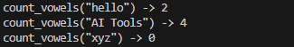

Comparison & Explanation:

Aspect | Zero-Shot | Few-Shot
Logic clarity | Basic loop | Optimized logic
Accuracy | Correct | Correct
Code quality | Simple | Cleaner & concise
Guidance | No examples | Clear behavior from examples

Justification:
Few-shot prompting improves output quality because examples clarify expected behavior, edge cases, and efficiency. The model generates more refined and optimized solutions when patterns are visible.

Task Description-5
• Use few-shot prompting with 3 sample inputs to generate a function that determines
the minimum of three numbers without using the built-in min() function.
Expected Output-5
• A function that handles all cases with correct logic based on example patterns.

Prompt:
Example 1: (3, 7, 5) → 3
Example 2: (10, 2, 8) → 2
Example 3: (4, 4, 9) → 4
Write a Python function to find the minimum of three numbers without using min()

Code:
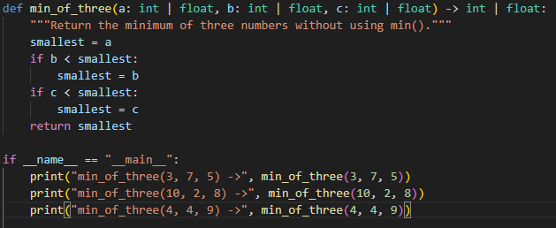

OUTPUT:
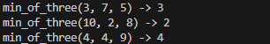

JUSTIFICATION:
Few-shot examples help the AI understand comparison logic and edge cases without using built-in functions. The model learns the decision pattern from examples and applies it correctly. This results in accurate handling of all possible inputs.

